**Decision Tree - Regression**

Decision tree builds regression or classification models in the form of a tree structure. It breaks down a dataset into smaller and smaller subsets while at the same time an associated decision tree is incrementally developed. The final result is a tree with decision nodes and leaf nodes. A decision node (e.g., Outlook) has two or more branches (e.g., Sunny, Overcast and Rainy), each representing values for the attribute tested. Leaf node (e.g., Hours Played) represents a decision on the numerical target. The topmost decision node in a tree which corresponds to the best predictor called root node. Decision trees can handle both categorical and numerical data.

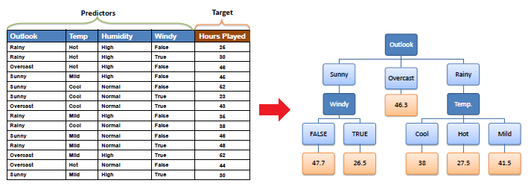

|  |  |  |
| --- | --- | --- |
|  |  |  |
| **Decision Tree Algorithm**  The core algorithm for building decision trees called **ID3.**  The ID3 algorithm can be used to construct a decision tree for regression by replacing  **Information Gain** with ***Standard Deviation* *Reduction***.  Standard deviation for **one** attribute:  http://www.saedsayad.com/images/Decision_tree_r2.png |  |  |

* Standard Deviation (**S**) is for tree building (branching).
* Coefficient of Deviation (**CV**) is used to decide when to stop branching. We can use Count (**n**) as well.
* Average (**Avg**) is the value in the leaf nodes

Standard deviation for **two** attributes (target and predictor):

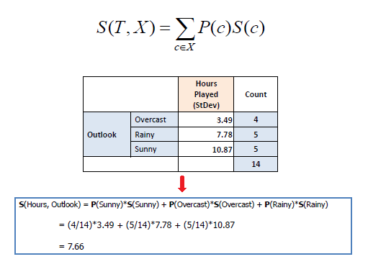

|  |  |  |
| --- | --- | --- |
|  |  |  |
| **Standard Deviation Reduction** :  The standard deviation reduction is based on the decrease in standard deviation after a dataset is  split on an attribute. Constructing a decision tree is all about finding attribute that returns the highest  standard deviation reduction (i.e., the most homogeneous branches).     |  |  |  | | --- | --- | --- | | ***Step 1***: The standard deviation of the target is calculated. |  |  | |  |  |  | | **Standard deviation (Hours Played) = 9.32** |  |  | |  |  |  | | ***Step 2***: The dataset is then split on the different attributes. The standard deviation for each branch is calculated.  The resulting standard deviation is subtracted from the standard deviation before the split.  The result is the standard deviation reduction. |  |  | |  |  |
|  |  |  |

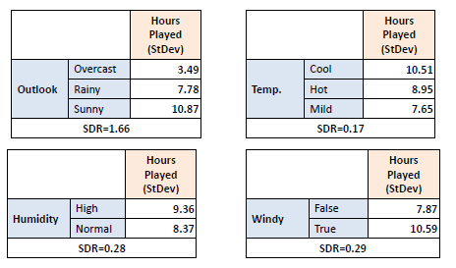

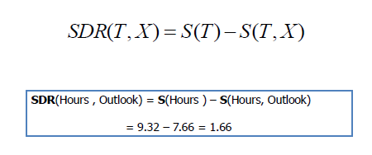

***Step 3***: The attribute with the largest standard deviation reduction is chosen for the decision node.

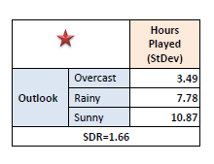

***Step 4a***: The dataset is divided based on the values of the selected attribute. This process is run recursively on the non-leaf branches, until all data is processed.

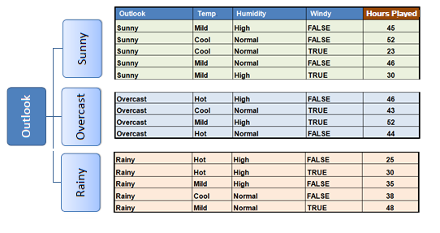

In practice, we need some termination criteria. For example, when coefficient of deviation (**CV**) for a branch becomes smaller than a certain threshold (e.g., 10%) and/or when too few instances (**n**) remain in the branch (e.g., 3).

***Step 4b***: "Overcast" subset does not need any further splitting because its CV (8%) is less than the threshold (10%). The related leaf node gets the average of the "Overcast" subset.

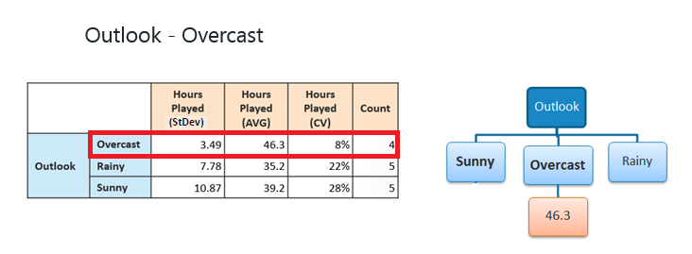

***Step 4c***: However, the "Sunny" branch has an CV (28%) more than the threshold (10%) which needs further splitting. We select "Windy" as the best best node after "Outlook" because it has the largest SDR.

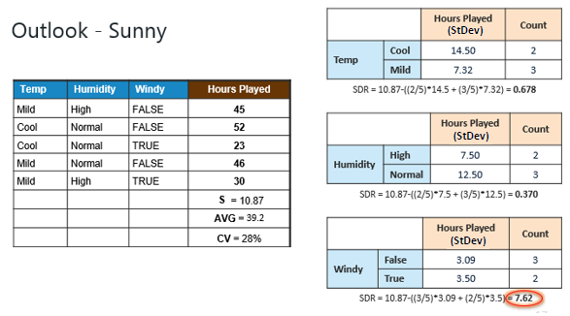

Because the number of data points for both branches (FALSE and TRUE) is equal or less than 3 we stop further branching and assign the average of each branch to the related leaf node.

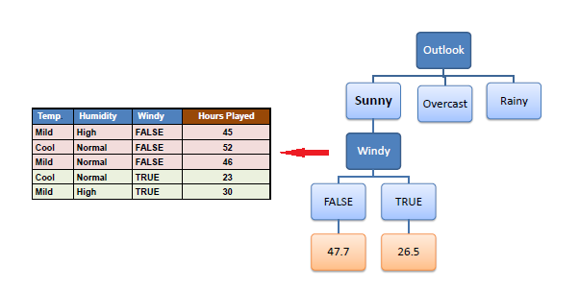

***Step 4d***: Moreover, the "rainy" branch has an CV (22%) which is more than the threshold (10%). This branch needs further splitting. We select "Windy" as the best best node because it has the largest SDR.

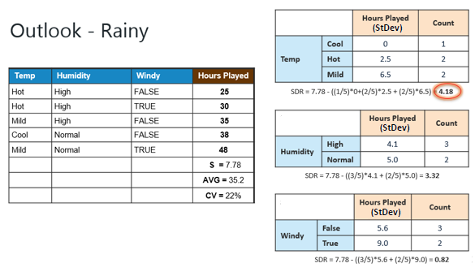

Because the number of data points for all three branches (Cool, Hot and Mild) is equal or less than 3 we stop further branching and assign the average of each branch to the related leaf node.

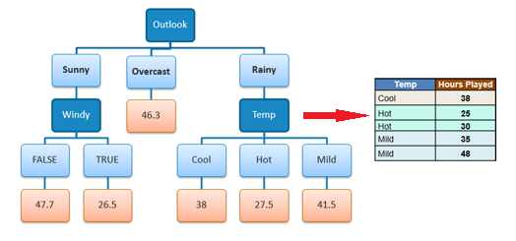

When the number of instances is more than one at a *leaf node* we calculate the *average* as the final value for the target.